Petitioner: Navroz F. Saju
Property Owner: City of Ocala
Agent: DOMACH, LLC
Project Planner: Kristina L. Wright, CNU-A, FRA-RA
Applicant Request: A request to abrogate the eastern one-hundred and sixty-four (164) feet of the alley between SW 2nd Avenue and SW 3rd Avenue (Parcel 2854-025-010); approximately 0.06 acres.
Subject Property Information
Acres: ±0.06 acres
Parcel#: 2854-025-010
Location: Alley between SW 2nd Avenue and SW 3rd Avenue
Existing use: 14-foot-wide alleyway
Future Land Use Designation: High Intensity/Central Core
Zoning Designation: FBC, Form-based Code District
Overlay(s): Downtown Community Redevelopment Area

Figure 1. Aerial Location Map
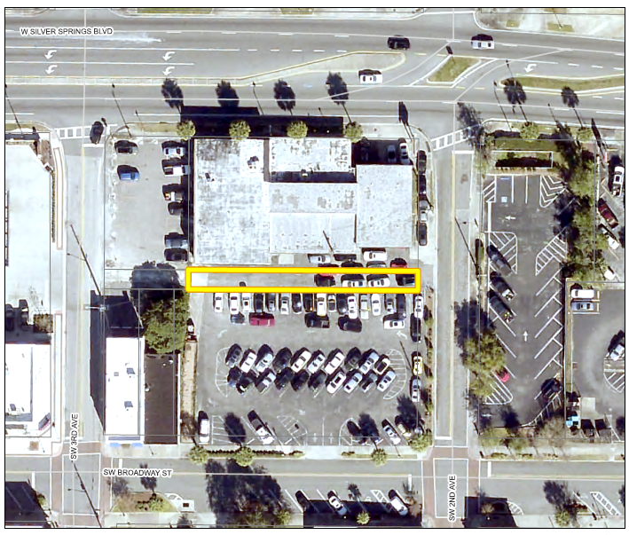

Adjacent Property Information
Direction | Future Land Use | Zoning District | Current Use
North | High Intensity /Central Core | FBC, Form-based Code | Vacant/undeveloped
East | High Intensity /Central Core | FBC, Form-based Code | Parking Lot
South | High Intensity /Central Core | FBC, Form-based Code | Vacant/undeveloped
West | High Intensity /Central Core | FBC, Form-based Code | Vacant/undeveloped and a former café and real estate office

Background
The subject alley, owned by the City of Ocala, is 14 feet wide and was historically used by the city for service access and utilities. Domach, LLC., owns the property on either side of the alley.
The portion of the subject alley being vacated runs east and west between SW 3rd Avenue and SW 2nd Avenue just south of SR 40 in the downtown area. The alley and surrounding area is located within the Form Based Code (FBC) zoning district and has an underlying land use of High Intensity/Central Core. The property is also within the Downtown Community Redevelopment Area. The applicant is requesting to abrogate the subject alley to allow for redevelopment of the property north and south of the intervening alley.

The subject 14-foot alley had city underground utilities that are in the process of being relocated. The northern portion of the property was formerly a repair garage doing business as European Car Clinic while the southern portion served as a surface parking lot.
This abrogation was approved by the Planning & Zoning Commission on November 13, 2023. The request never moved forward to City Council while ownership issues were resolved. The initial hearing occurred more than one year ago, meaning that a new hearing is now necessary.
Staff Analysis
If approved, the abrogation of this alley will not adversely affect connectivity, and the petitioner will become responsible for the maintenance of this strip of land. The northwesternmost parcel is currently vacant. Adequate access and frontage to the surrounding parcels exists, and if approved, the city will continue to maintain ownership of the western sixty feet of the subject alley.
Utility Responses
The utility responses are summarized as follows:
Utility | Date | Response
CenturyLink/Lumen:  Owen Hurley |  | No objection
Charter/Spectrum |  | No Response
Cox Communications | 9/27/2023 | No objection
Electric (OEU):  Donnie Fales | 11/06/2023 | No objection
Fiber:  Jessey Shoepke | 09/26/2023 | No objection
Duke Energy |  | No Response
Public Works:  Dwayne Drake | 09/26/2023 | No objection
TECO:  Landon Meahl | 9/27/2023 | No objection
Transportation:  Noel Cooper | 10/20/2023 | No objection
Water Resources:  Richard Ragosta | 09/26/2023 | No objection
Stormwater:  Payal Panda | 10/17/23 | No objection
Real Estate:  Tracy Taylor | 11/06/2023 | No objection
Surveying:  R. Kelly Roberts | 1/03/2025 | No objection

Staff Findings and Recommendation The requested abrogation does not adversely affect connectivity and will promote redevelopment within the downtown area. As such, staff recommends approval of the request to abrogate the eastern 164 feet of the alley located between SW 2nd Avenue and SW 3rd Avenue (Parcel 2854-025-010).

Staff Recommendation: Approval of ABR23-45350.

