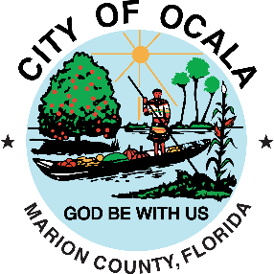

Hurricane Milton
FDEM & FEMA Emergency Management Recovery

Delegation of Authority
I, Kristen M. Dreyer, am the City Council President of the City of Ocala, Florida.

I authorize and delegate Peter Lee, City Manager to:
- Execute Funding Agreements and any amendments for additional funding as Designated Authorized Agent for the City of Ocala, Florida.
- Sign compliance report documents and other documents for FEMA & FDEM.

Please feel free to contact me with questions/requests for information.

SIGNATURE:_________________________________________________DATE:_____________________

PRINTED NAME & TITLE: Kristen M. Dreyer, City Council President______________________________

WITNESS SIGNATURE:_________________________________________DATE:_____________________

WITNESS PRINTED NAME:________________________________________________________________

